**MIT app codes and Blocks**

|  |  |
| --- | --- |
| Date | 12 December 2022 |
| Team ID | PNT2022TMID08806 |
| Project Name | Hazardous Area Monitoring for Industrial Plant powered by IoT |

# Screen 1: Designer & Blocks

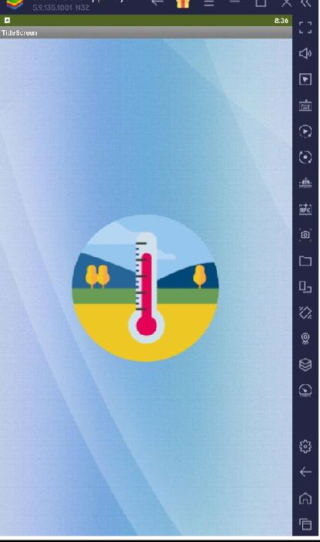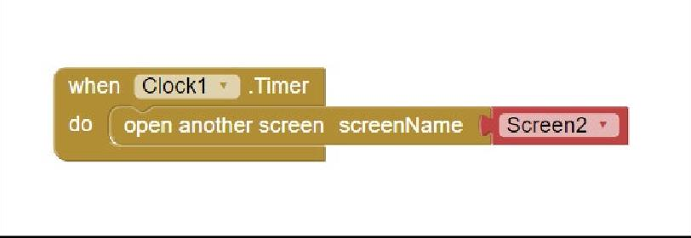

**Screen 2:**

# Designer & Blocks

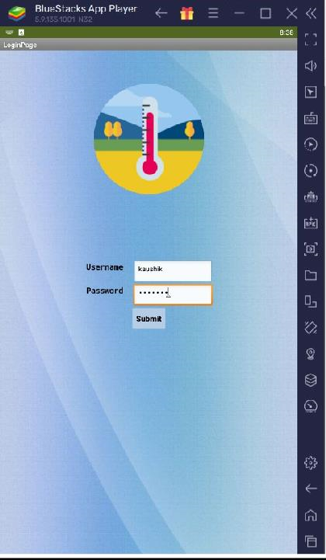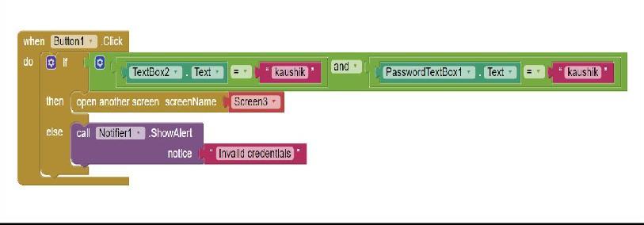

**Screen 3:**

# Designer & Blocks

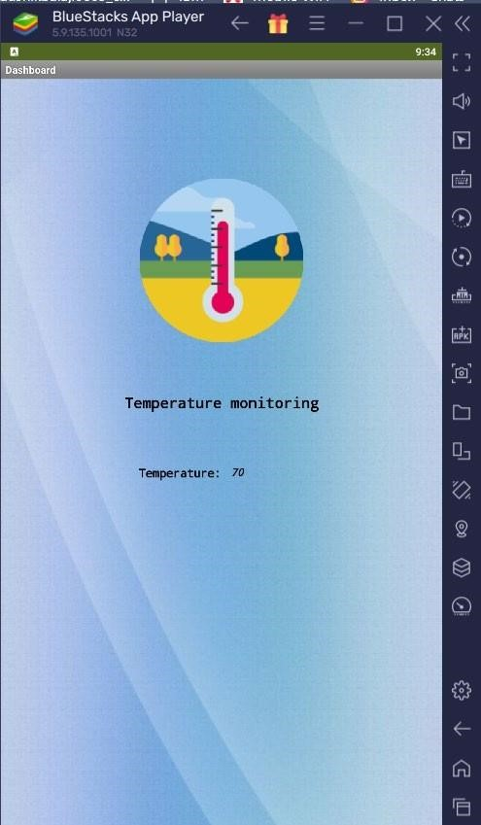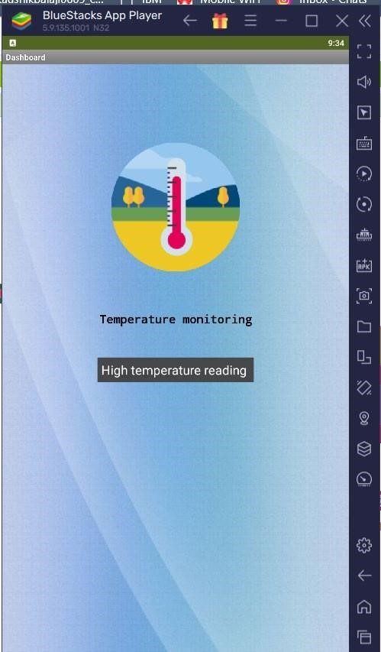

## Block for receiving value from the site

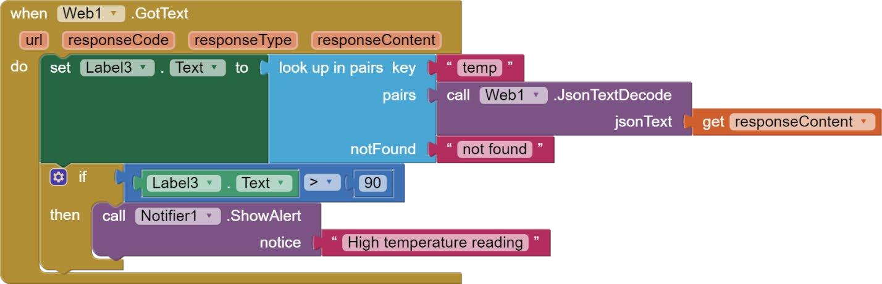

## Block for connecting the screen to required site

